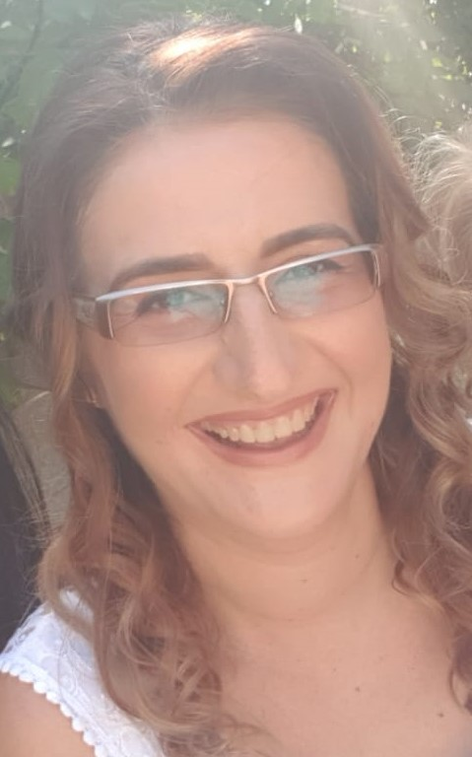
Bezem Ana –Maria

Junior lecturer, PhD student, Faculty of Psychology and Educational Sciences, University “Ovidius” from Constanța
The main areas of expertise and research include:
1. implementation of programs, methods and strategies of instruction and differentiated intervention specific to the needs of children and young people with disabilities / SEN;
2. identification and integration of children and young people with specific learning disorders (dyslexia-dysgraphia, dyscalculia) in differentiated educational programs.
Training in “Clinical Hypnosis, Relaxation and Ericksonian Therapy”, Authorized Neurolinguistic Programming Practitioner (International NLP Foundation Bucharest), Senior Autonomous Psychologist, specialized in Special Education.

