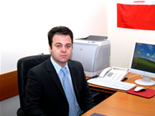

Șef lucrări univ.dr.Gheorghe Lucian

Gheorghe Lucian is a graduate of law and psychology ("Ovidius" University of Constanta). He is a Ph.D. lecturer in the Faculty of Mechanical Engineering and Industrial Maritime, Department of Industrial Management and Automotive. Areas of expertise are: legal sciences and psychology and the research directions can include: work legislation, legislation in the economic, social assistance legislation, legal psychology and engineering psychology.

