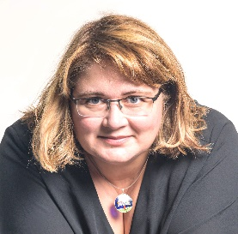

Lecturer. PhD Laura Mariana Popa

Laura Popa is a graduate of the Faculty of Natural Sciences ("Ovidius" University of Constanța) and a doctor of biology ("Ovidius" University of Constanța). His experience has been consolidated as a teacher and trainer for students and adults in areas such as biology, interpersonal and didactic communication, team coordination, management and leadership, non-formal education, debate and argumentation, health education, neuroscience, ecology. His interests are towards experiential learning so that each person finds in their own universe the power to initiate and sustain change.