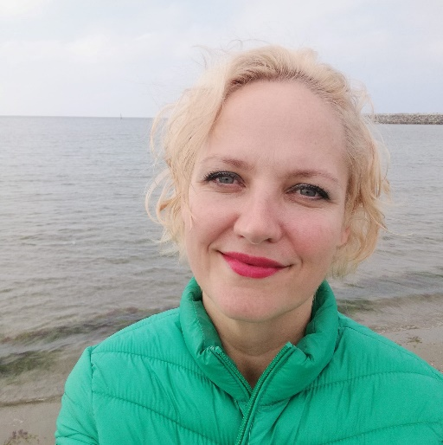

**Associate University Lecturer Ph.D. Ecaterina Gabriela Totolan**

She is a graduate of the University of Bucharest, Faculty of Sociology, Psychology and Pedagogy, specialization in Special Psychopedagogy, Doctor of Psychology (University of Bucharest, scientific coordinator Prof. Univ. Dr. Emil Verza). The main activity is that of speech therapist at the County Center for Resources and Educational Assistance Constanța, has 23 years of experience in the field of speech therapy and is a collaborator of the University "Ovidius" Constanța since 1999 in disciplines aimed at therapy of language disorders, but and other.

Additional information: CV