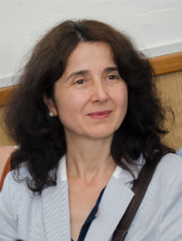

Daniela Căprioară has a bachelor’s degree both in Mathematics and Psychology and a PhD in Educational Sciences. Her experience covers: Mathematics education, Research in Educational Sciences, Computer-assisted Training, Educational Management, Development of digital skills, Management of Educational Projects.

Her research interests include Learning and Teaching Mathematics, Mathematics curriculum, Psychology of learning Mathematics, School Assessment, Financial Education, Development of transversal skills, Initial and in-service teacher training.

Additional information: CV