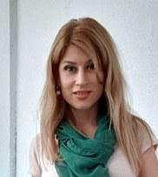

Mirela Mihaela Doga is a doctor in philology, full professor of the "Ovidius" University of Constanța, Faculty of Psychology and Educational Sciences, DPPD. She provided seminar activities for romanian language / literature courses. She currently coordinates the specialized practice of the students from the Faculty of Psychology and Educational Sciences, as well as of the students / masters enrolled in the psycho-pedagogical training module. She also holds an English seminar for Psychology and Social Work students. She appreciates innovation, is empathetic and passionate about reading, theater, art and travel.