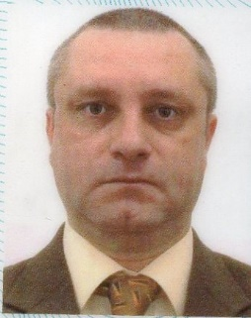

**Lect.univ.dr. Damian Mircea Totolan**

A graduate of Special Needs Psychopedagogy specialization and of an "Integrated Education" Master’s Degree, Damian Totolan holds a PhD in Psychology (Faculty of Psychology and Educational Sciences, University of Bucharest) and has been a member of our faculty team since its very beginning in 1999. His expertise as a teacher and speech therapist offers him a great perspective on the courses he teaches and provides him with a good understanding of individuals with special needs. His main research interests regard topics such as the self-image of people with disabilities as compared to people with typical development and the socio-professional integration of people with disabilities.

Additional information in the CV.