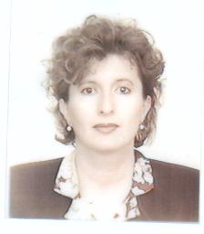

PhD Lecturer at "Ovidius" University of Constanta, Faculty of Psychology and Education Sciences. Doctor, with the distinction *Cum laude*, in the field of philology, specialization of English stylistics. Teacher and Examiner authorized by the London Chamber of Commerce and Industry for LCCI courses and exams - English for Business, English for Tourism and Junior and Senior English Tests. Teacher accredited internationally with the TESOL Diploma (Teaching English to Speakers of Other Languages).