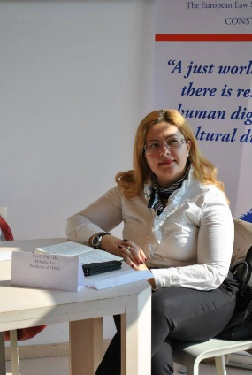

Mihaela Rus is a PhD. Professor at Ovidius University in Constanța, Romania, a professional psychologist with over 20 years of experience in this field, organizational and traffic psychology, she is a PhD supervisor in Psychology.

          Author of 10 books and over 80 specialized studies published in national and international journals, member of the scientific committees of prestigious national conferences.

          Since 2015, she is the president of the Psychology and Road Safety Association, coordinating 5 social responsibility campaigns at national level and the president of the College of Psychologists - Constanța branch.